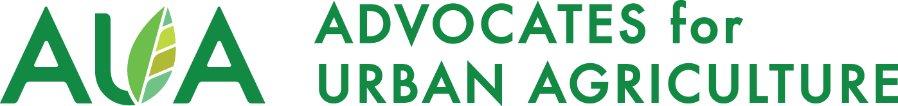

Farmer to Farmer Mentorship Program

AUA’s Farmer to Farmer Mentorship Program seeks to match beginning farmers with experienced farmers to share in their wealth of knowledge and foster mutually beneficial relationships. This program seeks to expand: educational opportunities for growing food,
flowers, medicine, farming animals and insects in Chicago; access to quality, safe food; skills for environmental conservation of soil, water, and air in our region; and the web of collective power and solidarity amongst Chicago area farmers.

We’re looking for a variety of beginning and experienced growers to participate in this program throughout February 2022 - December 2022. Once matched, mentors and mentees are free to structure the relationship to fit their schedules. Mentors are compensated for sharing their knowledge while mentees are given the opportunity to learn in-depth what it is to be a farmer at no cost. Mentors are expected to encourage good practices and assist the mentee in striving towards a successful growing operation and participating in the urban agriculture system. This cohort will consist of up to 15 pairs. Application does not guarantee acceptance or participation in the program.

While the focus is on the viability and scalability of urban farm businesses, home, school, or community gardeners are encouraged to apply as well. For additional support in those areas, please see AUA's Urban Agriculture Resource Guide for a comprehensive listing of applicable resources and local organizations.

This program, by farmers and for farmers, seeks:

- Mentors: Farm business owners, farmer trainers, experienced composters, experienced beekeepers, farmed animal keepers, permaculture instructors, controlled environment and indoor growers.

- Mentees: Beginning farmers, new farm business owners, Large Lot or property owners
interested in starting a farm business and/or community garden, farmers looking to expand their operation into new activities.

Mentors will be compensated at a rate of $25/hour, up to 30 hours per cohort. This program is free to mentees receiving mentorship. All program participants must be available February 28th, 2022 at 6pm Central time for orientation.

If you are interested, please submit a completed google form application, and résumé or summary of relevant experience, by Tuesday February 15th, 2022 at 11:59pm Central time. If you would like a downloadable copy of the application to fill out and mail or email in you can download them below: Email application to jazmin@auachicago.org or mail to: Advocates for Urban Agriculture, PO Box 168083, Chicago, IL 60616. If you are mailing an application, send an email or call to notify.

Download the Mentor Application | Download the Mentee Application

Equal Opportunity Statement: AUA works affirmatively to foster inclusive programming and does not discriminate in the selection of participants on the basis of race, color, religion, sex, national origin, age, sexual orientation, disability, income, marital status, or any other dimension of identity.
AUA strongly encourages applications from candidates and individuals with voices that have been historically under-represented in the food system, including but not limited to women, people of color, Black and Indigenous people.

